

**UNIVERSITI MALAYSIA TERENGGANU**

**CSM 3023 WEB BASED APPLICATION DEVELOPMENT**

**BACHELOR OF COMPUTER SCIENCE (MOBILE COMPUTING)**

**LAB 2**

**SEMESTER II 2023/2024**

**PREPARED FOR:**

**DR. MOHAMAD NOR BIN HASSAN**

**PREPARED BY:**

**NUR IZZATI NAJWA BINTI MOHD BAKHRI (S65417)**

**TASK 1: DATA SHARING IN SERVLET**

Index.html

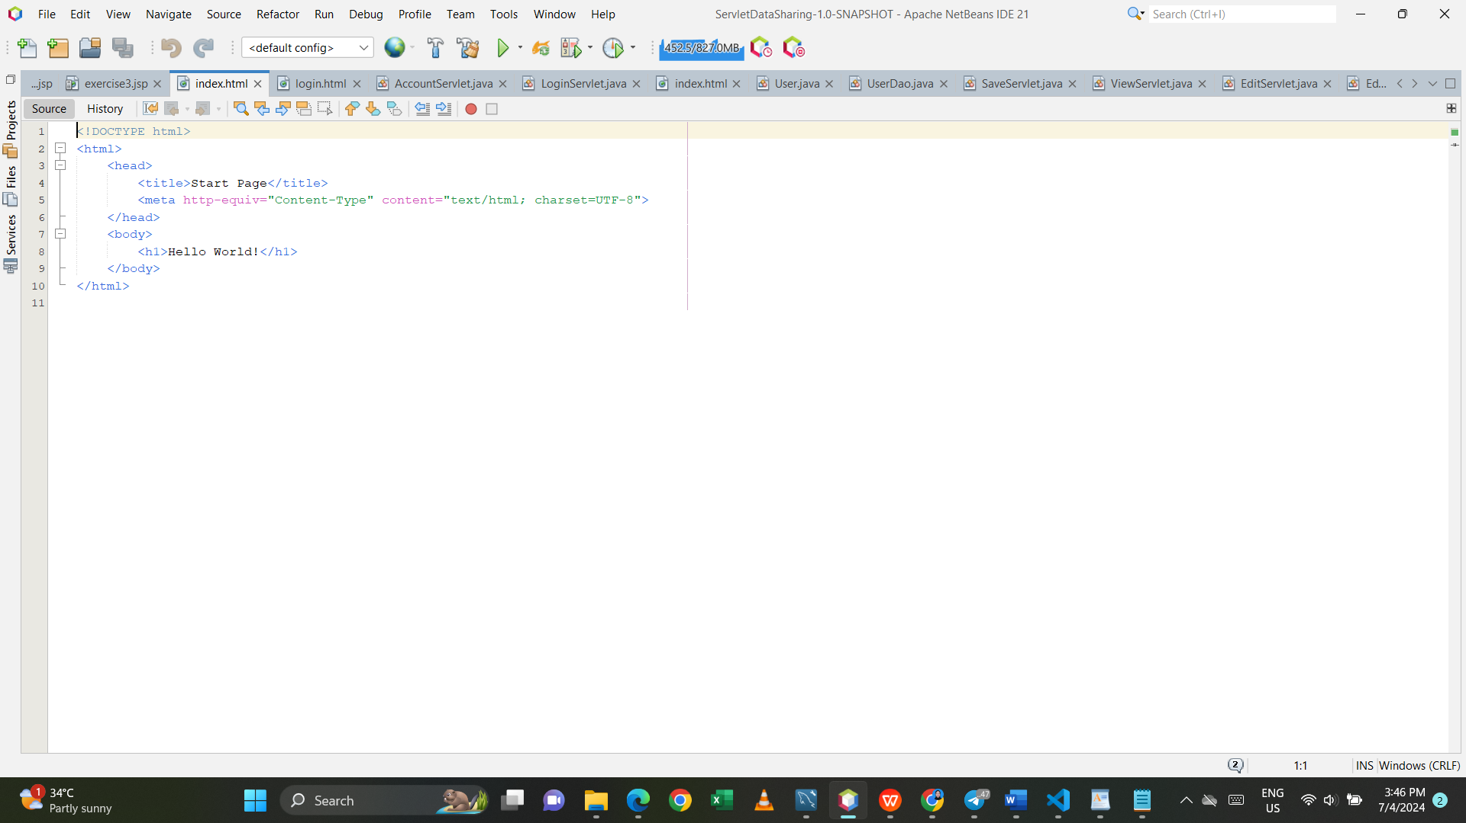

Login.html

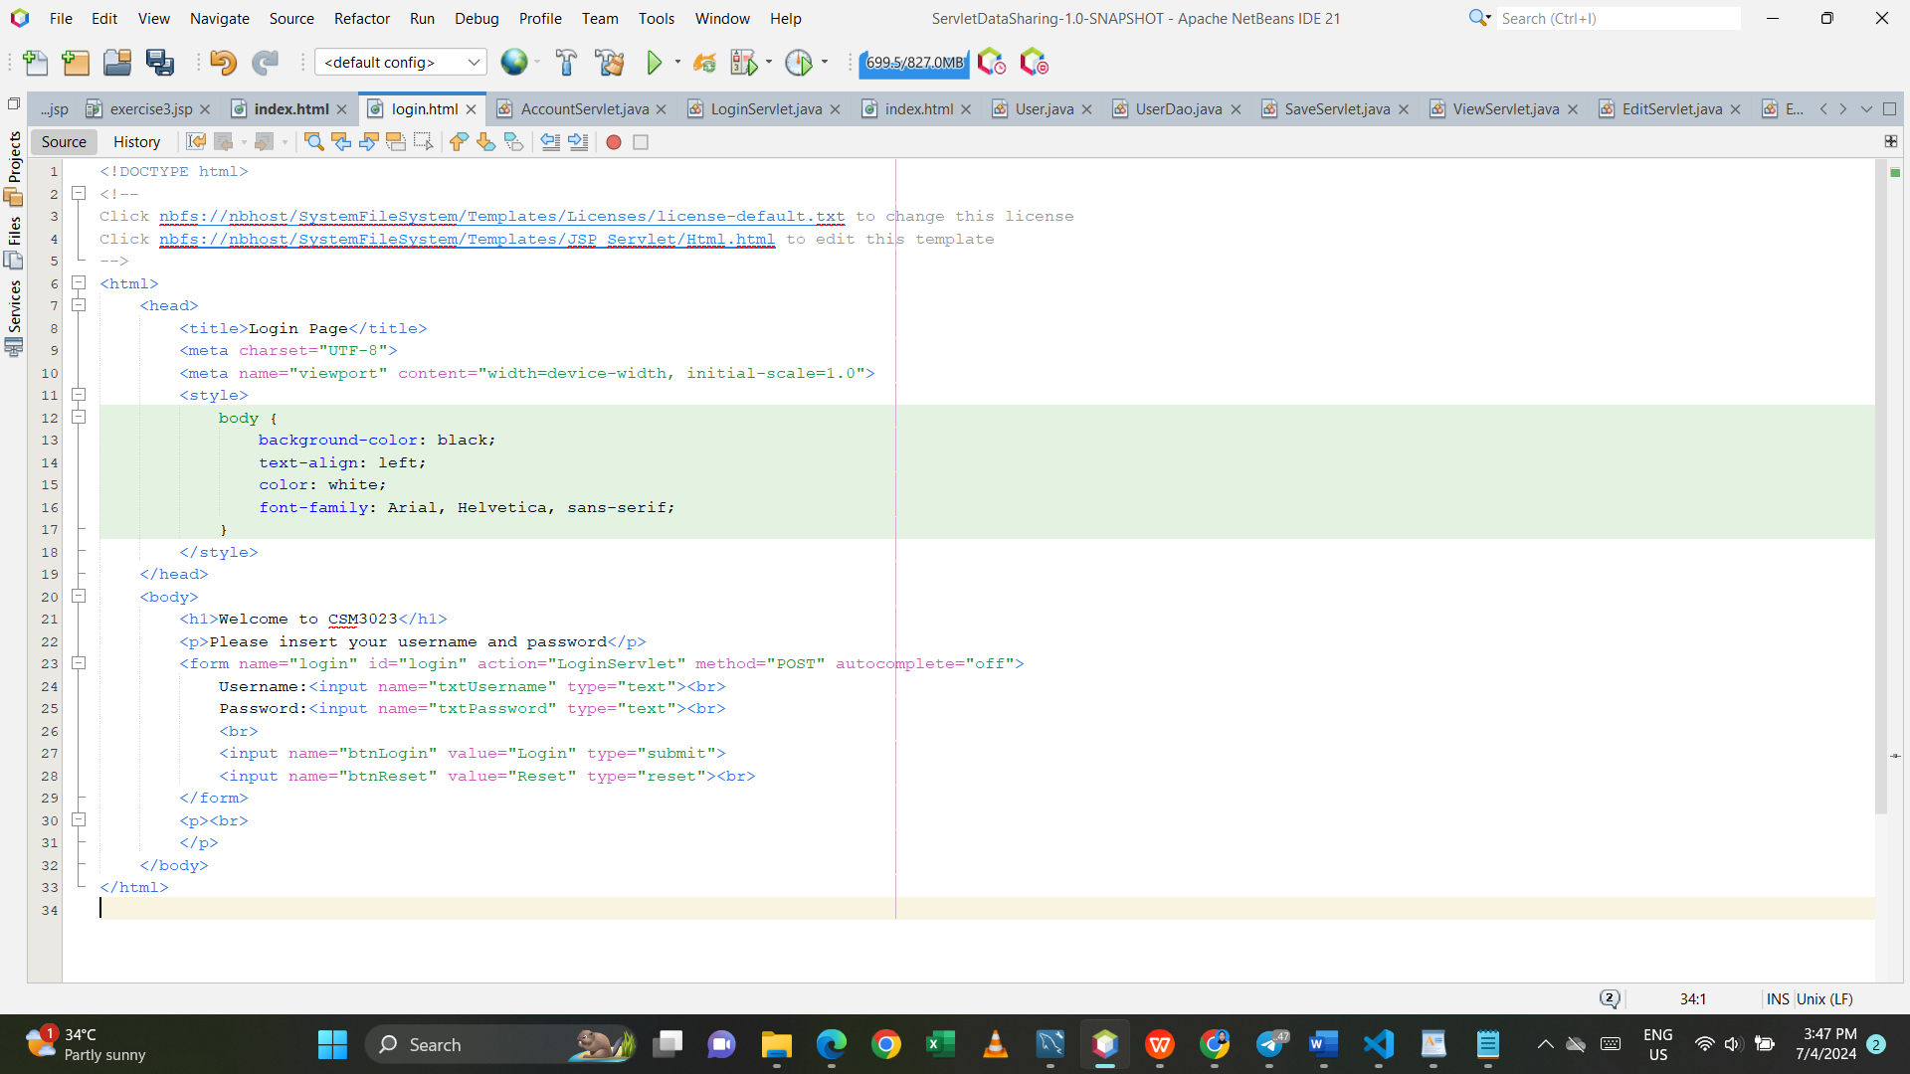

AccountServlet.java

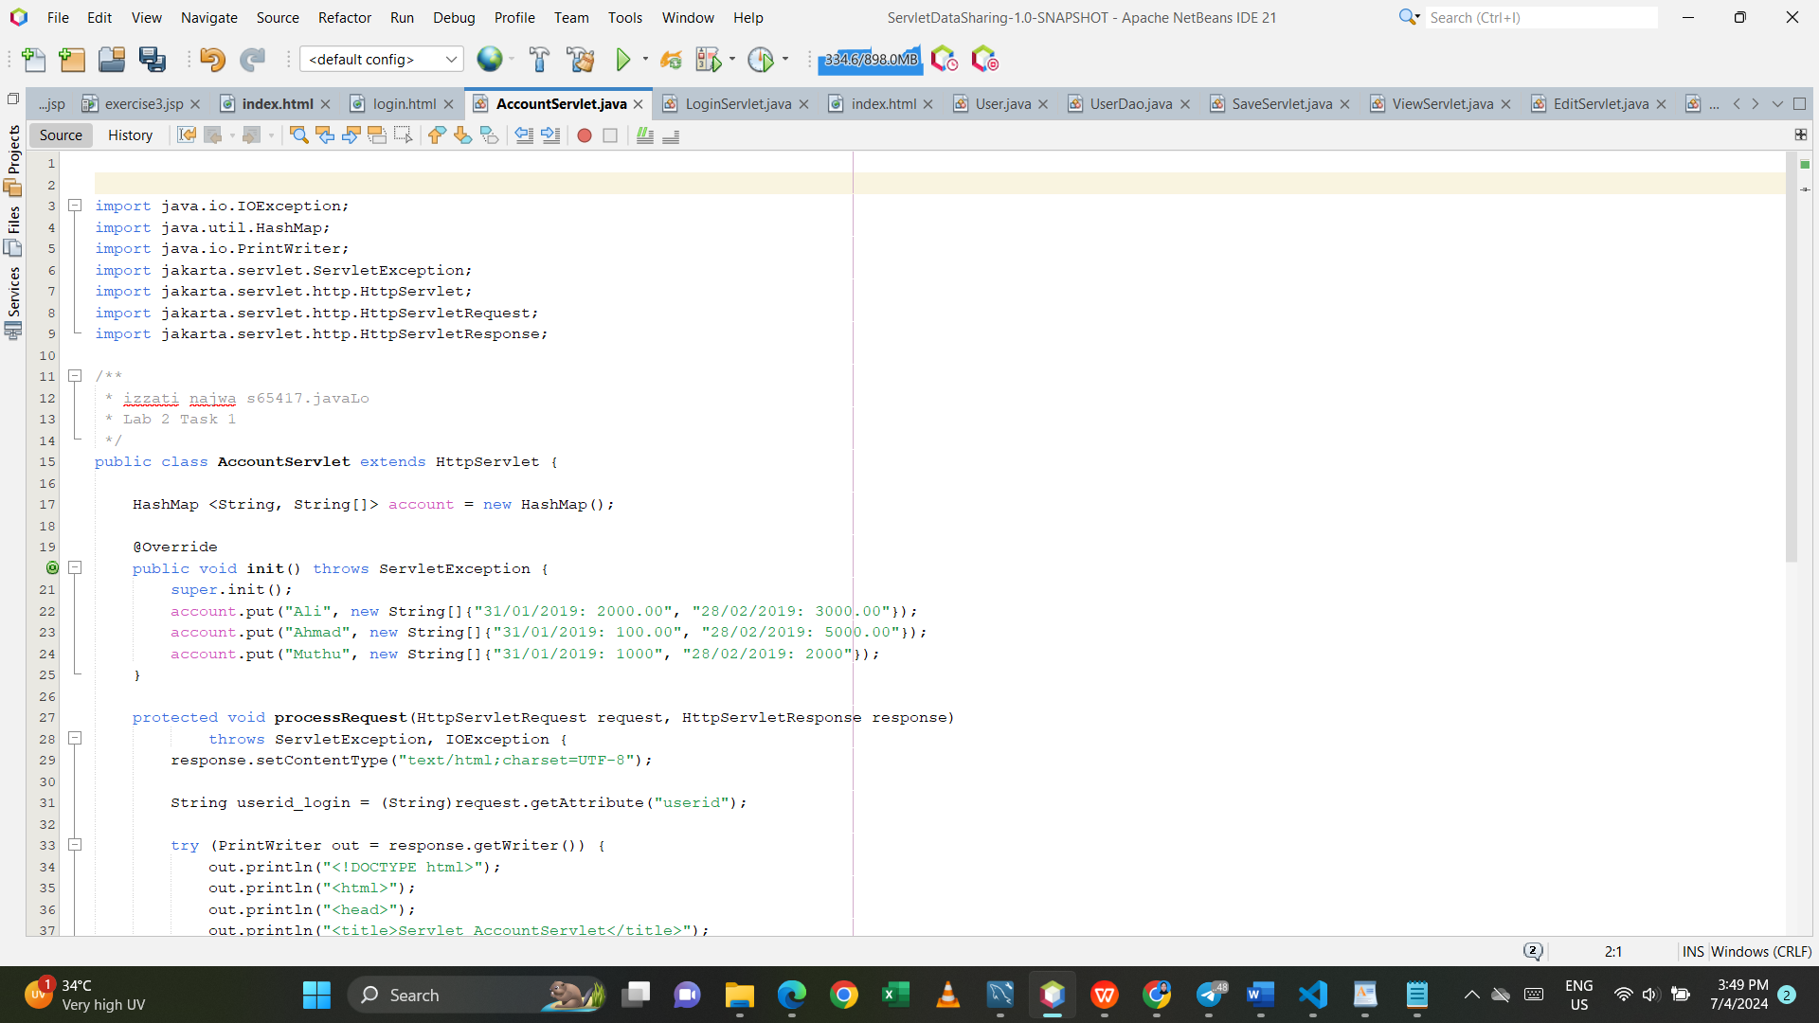

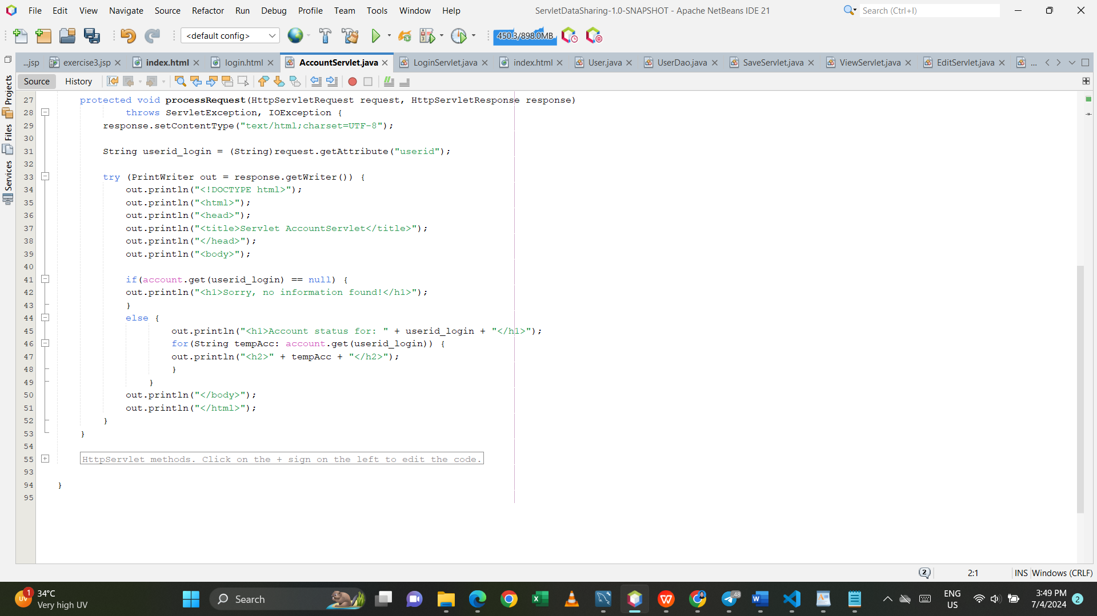

LoginServlet.java

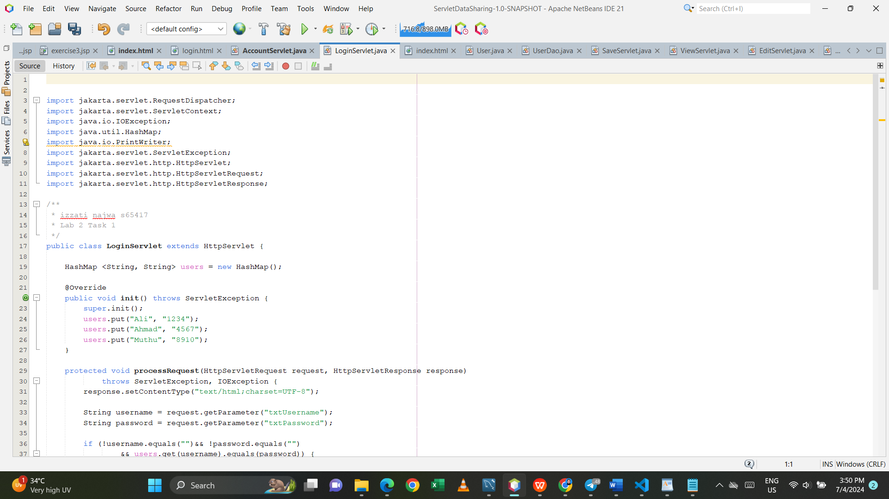

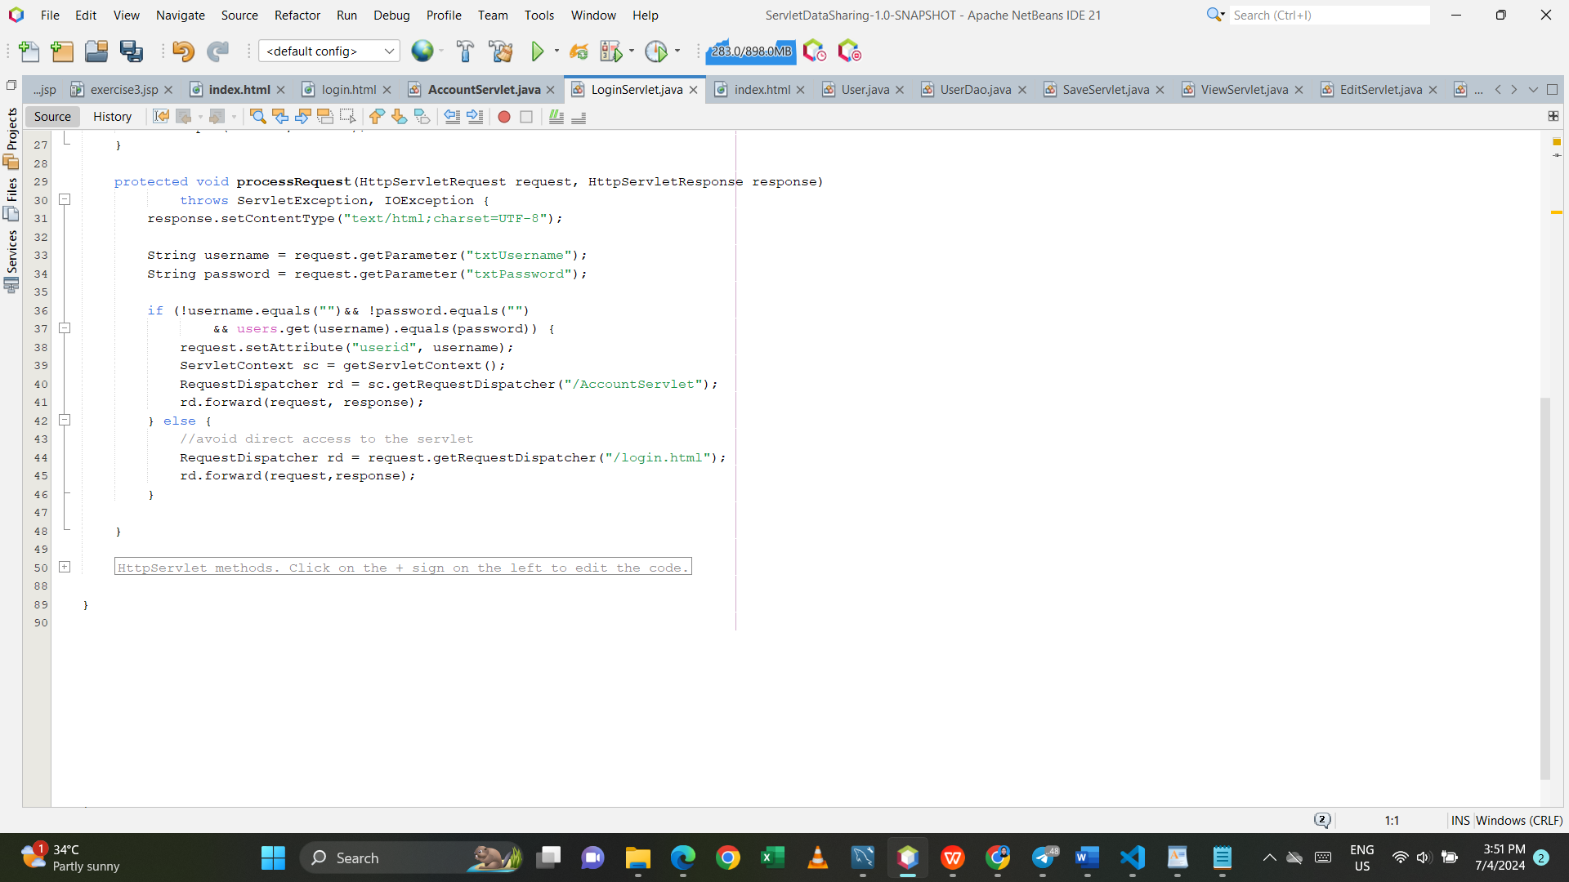

Output:

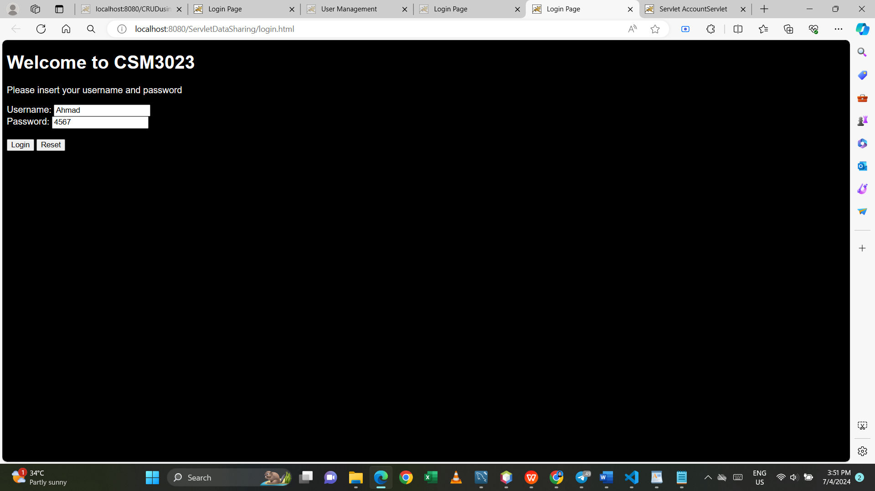

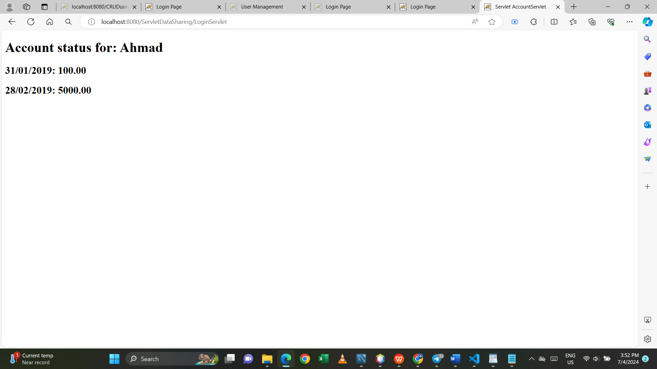

# Reflections:

* 1. What have you you learnt from this exercise?
* I learn how to connect file and use HashMap.

* 1. What are the common methods used in Java Servlet?
* doGet() and doPost()

TASK 4: USING SERVLET FOR DATABSE CRUD OPERATIONS

Index.html

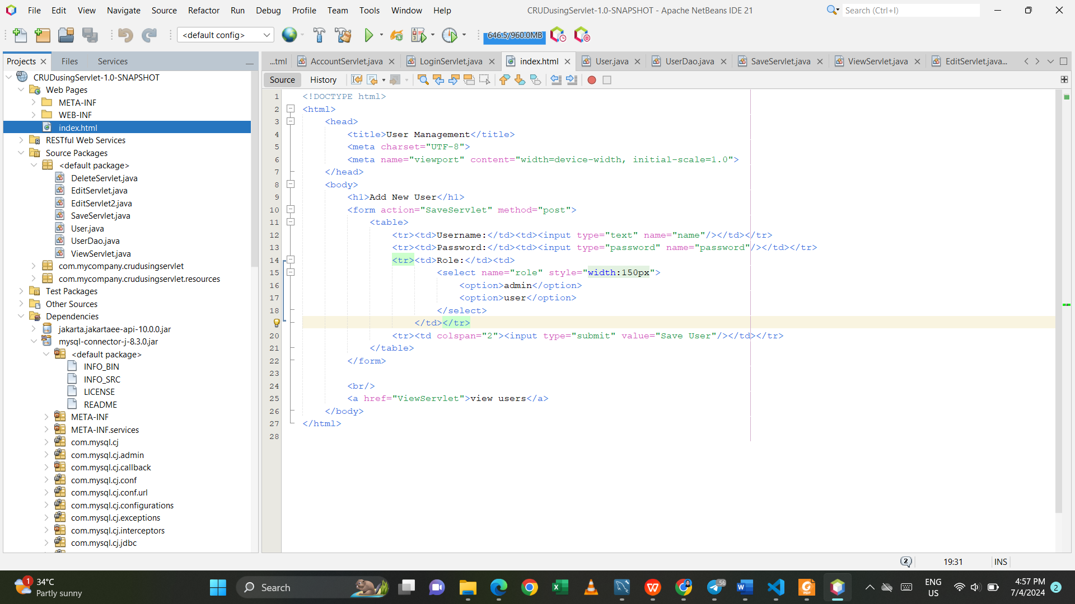

User.java

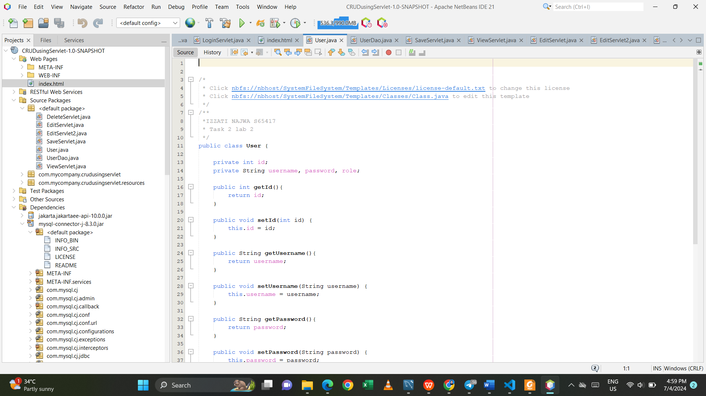

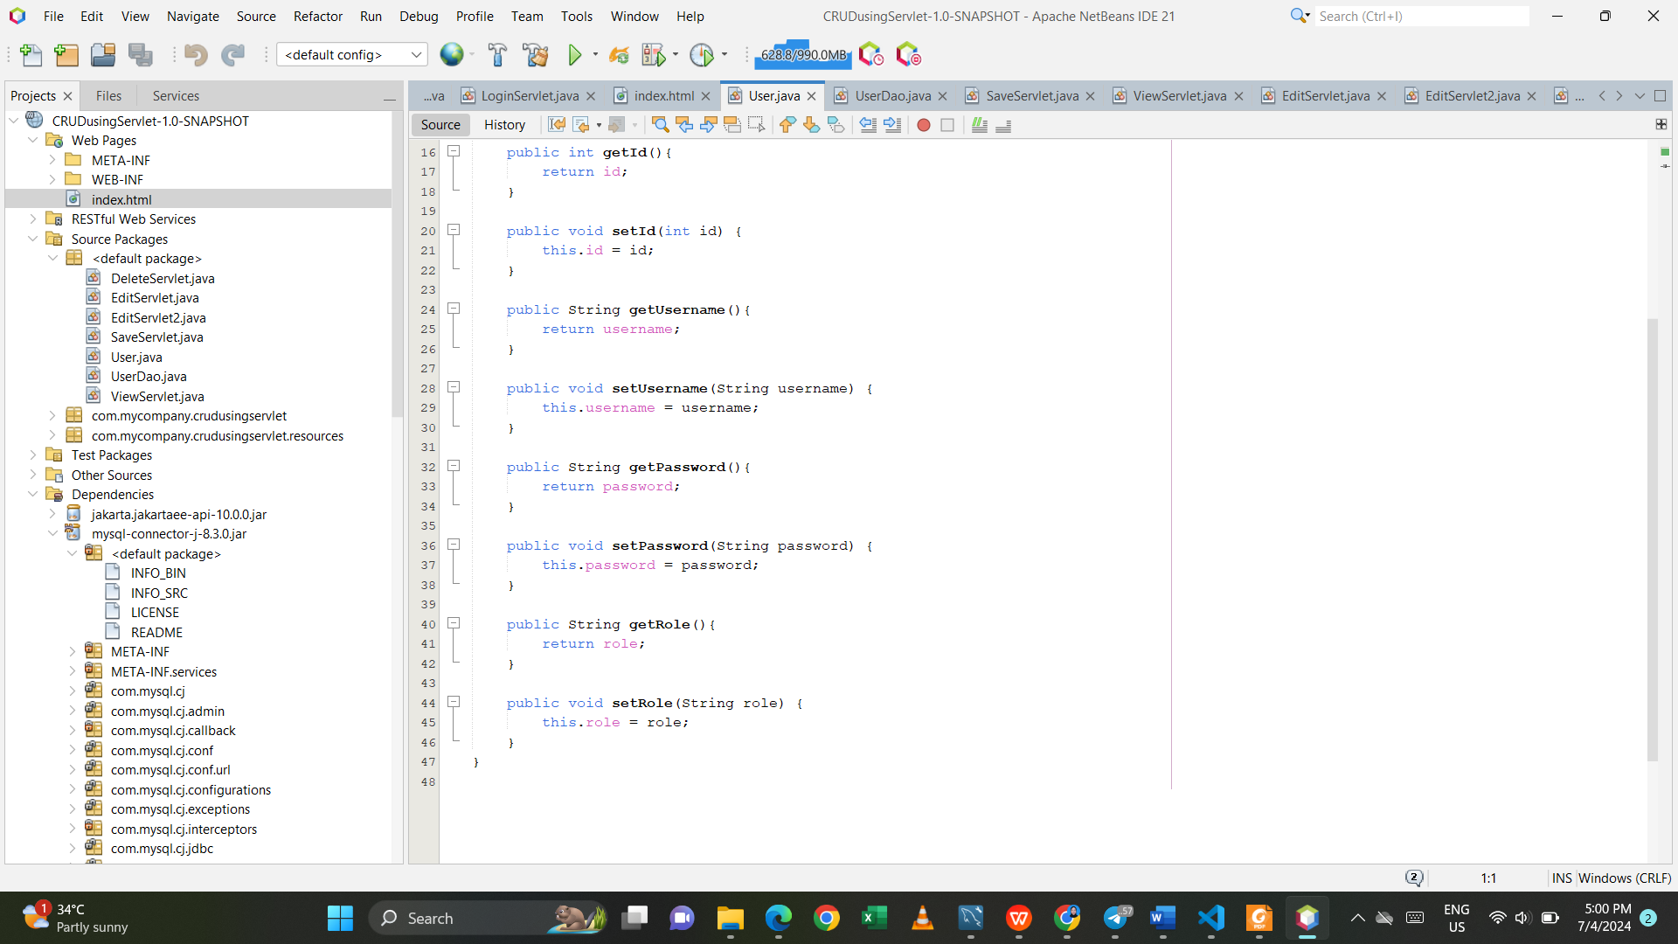

UserDao.java

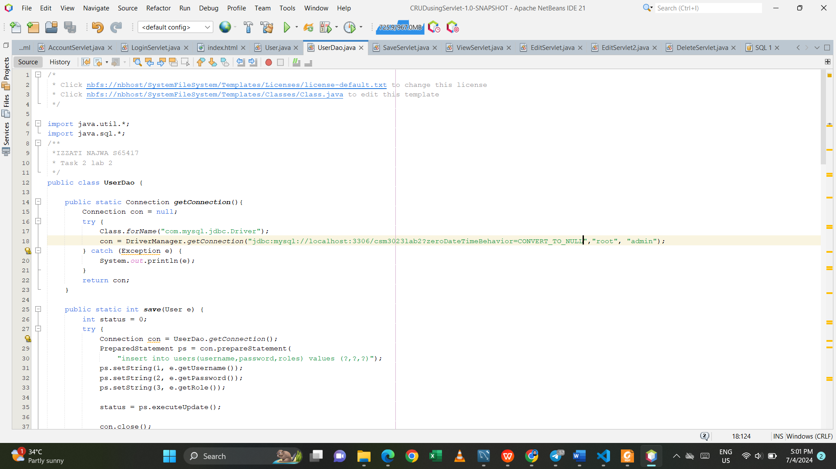

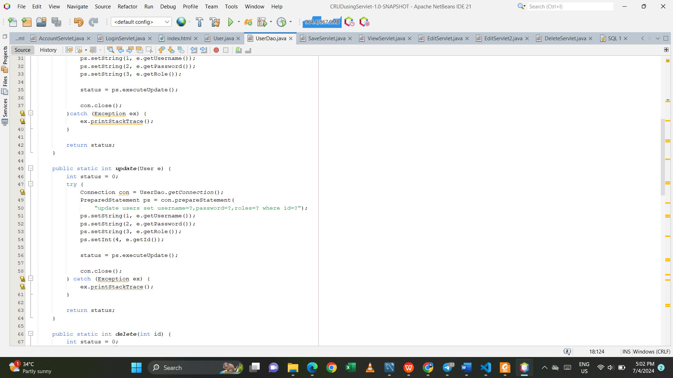

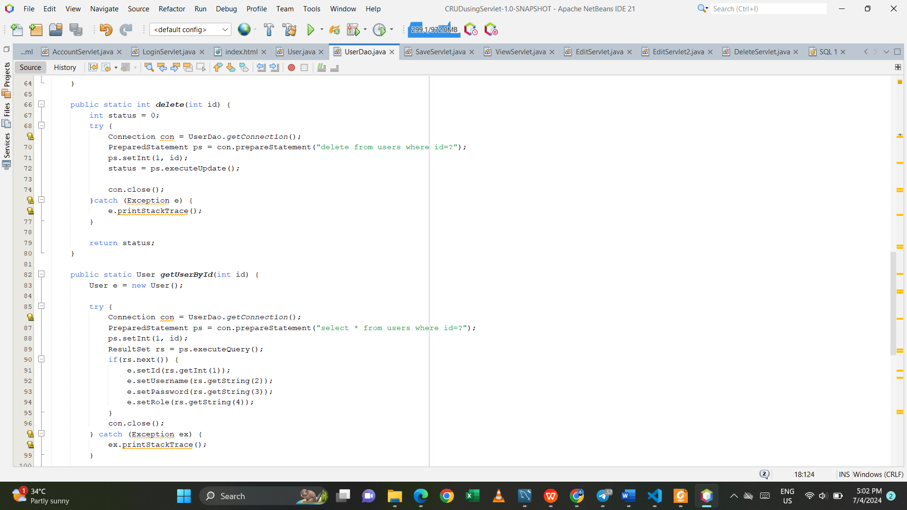

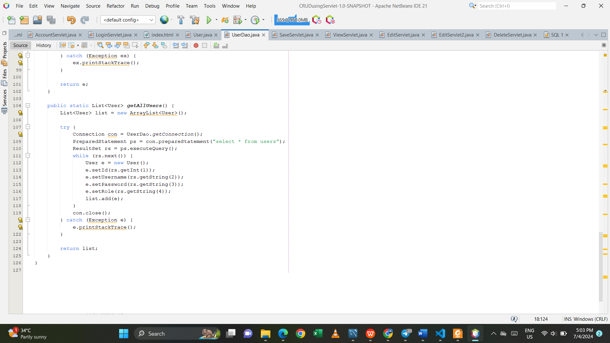

SaveServlet.java

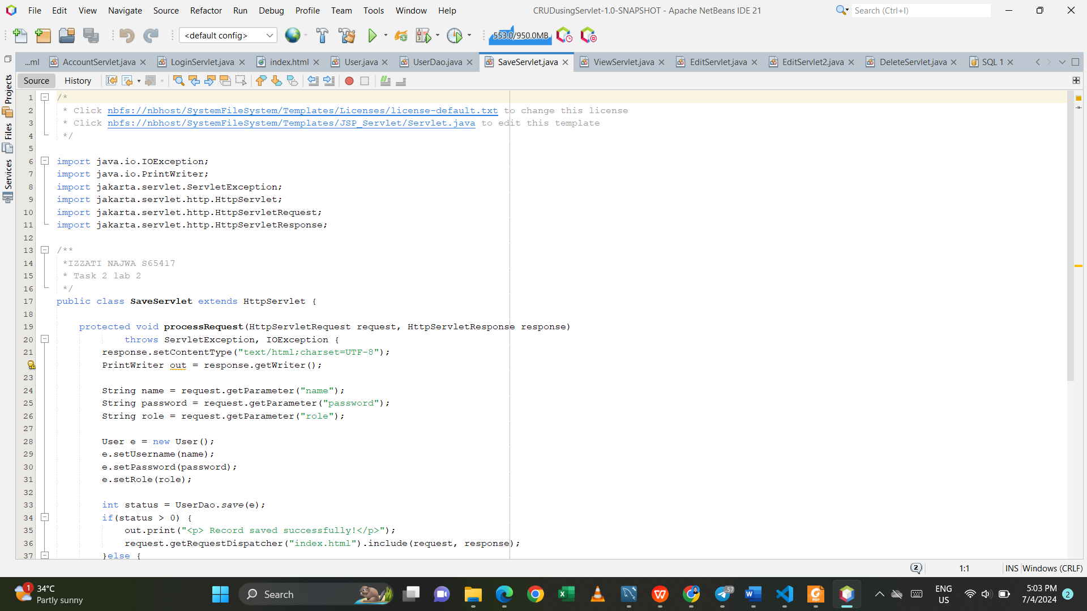

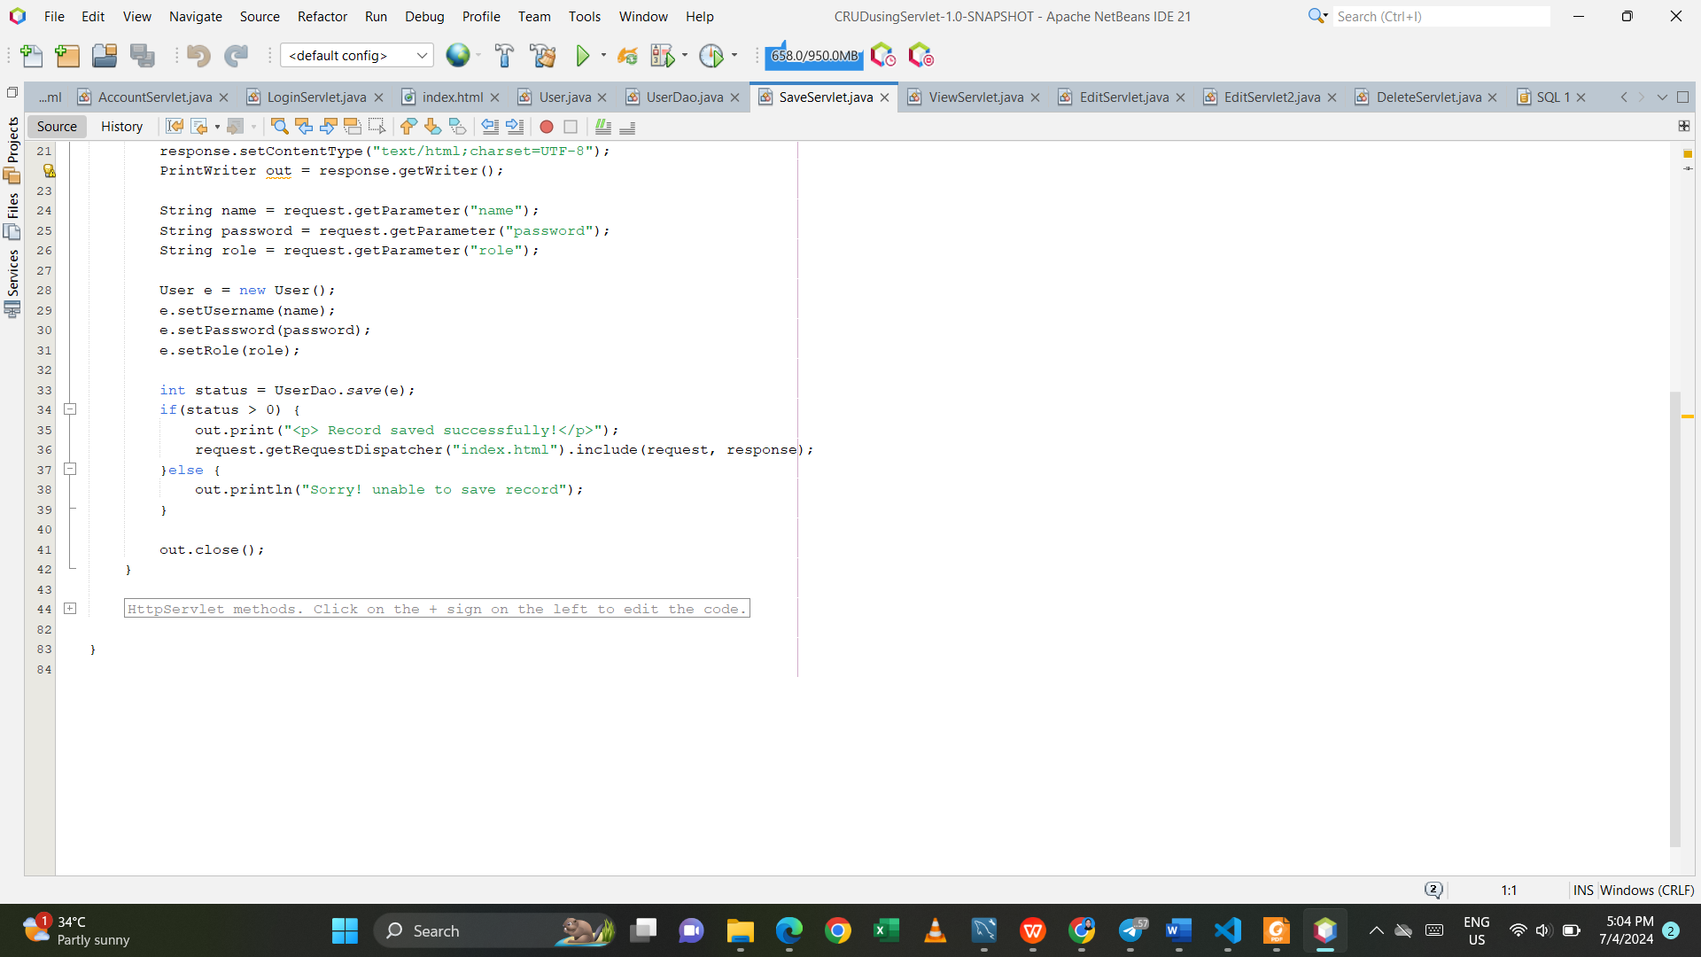

ViewServlet.java

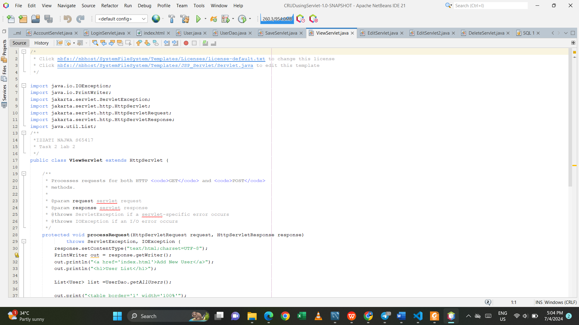

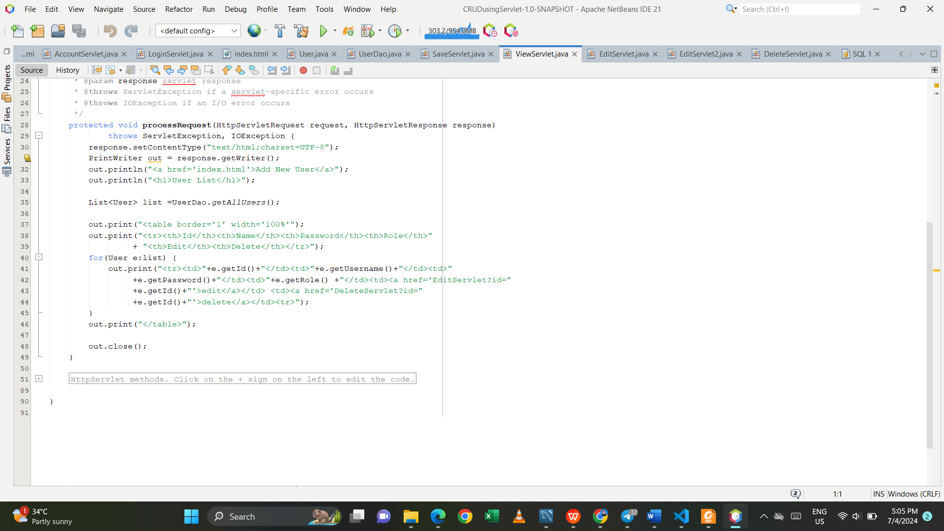

EditServlet.java

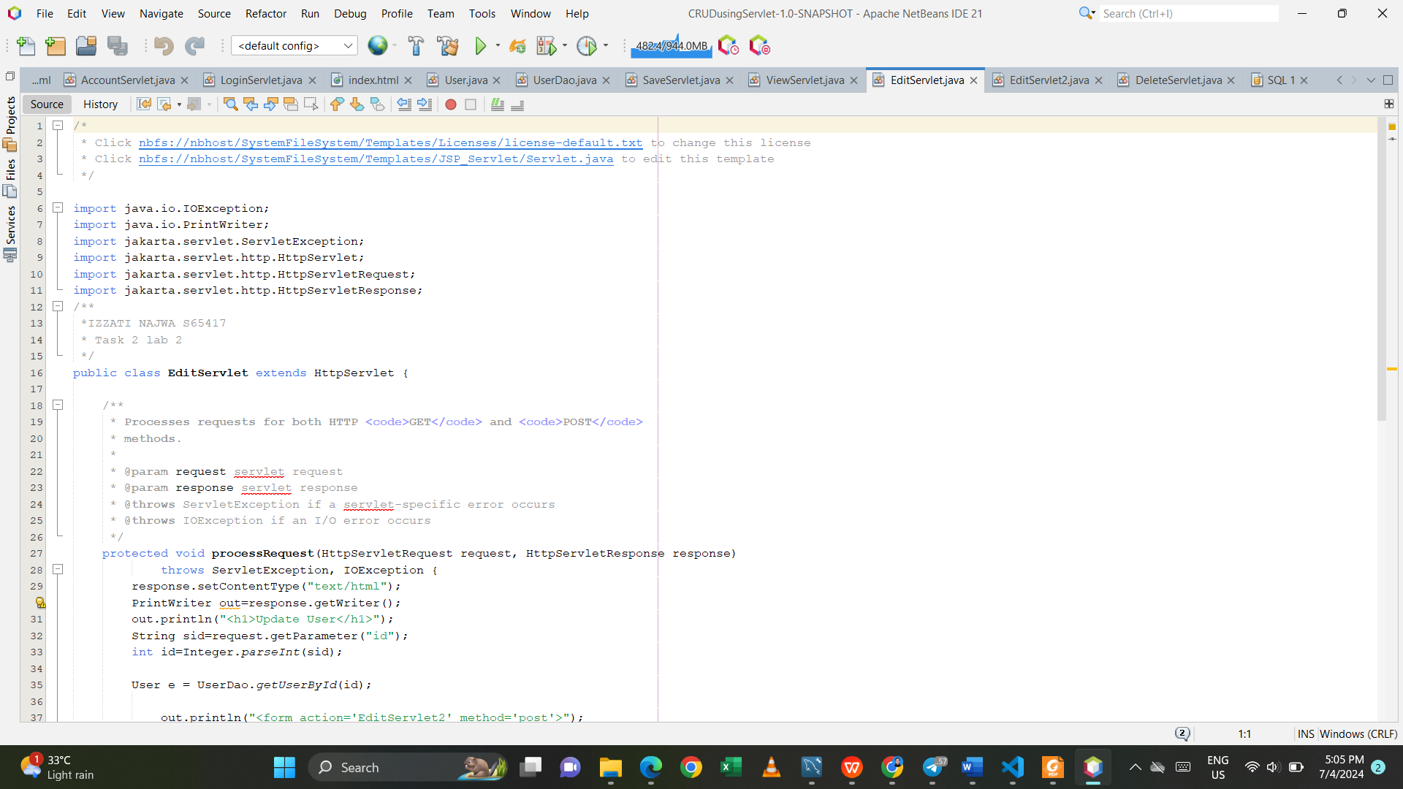

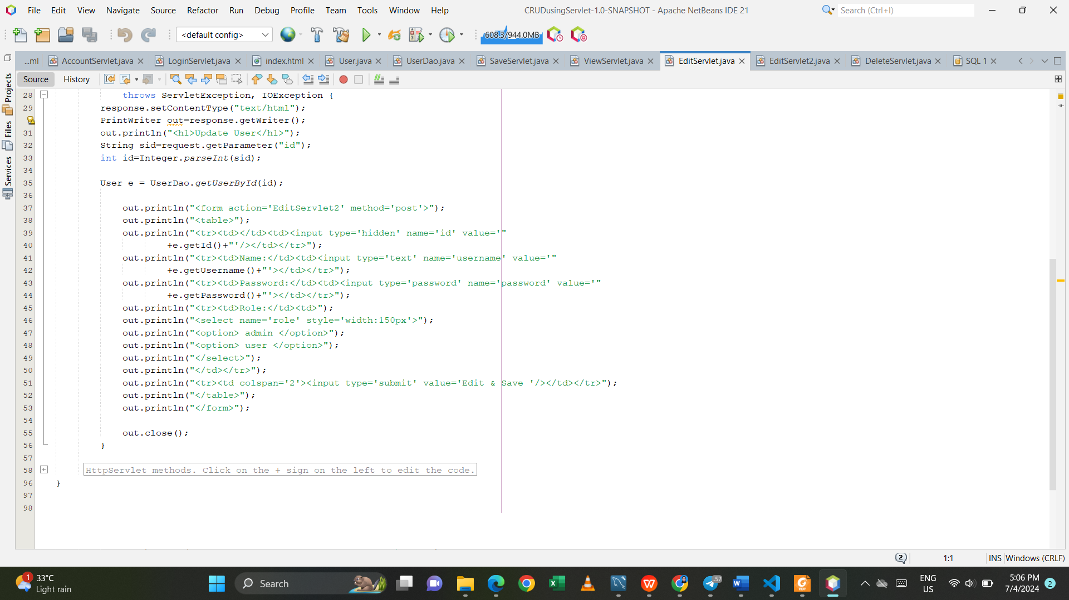

EditServlet2.java

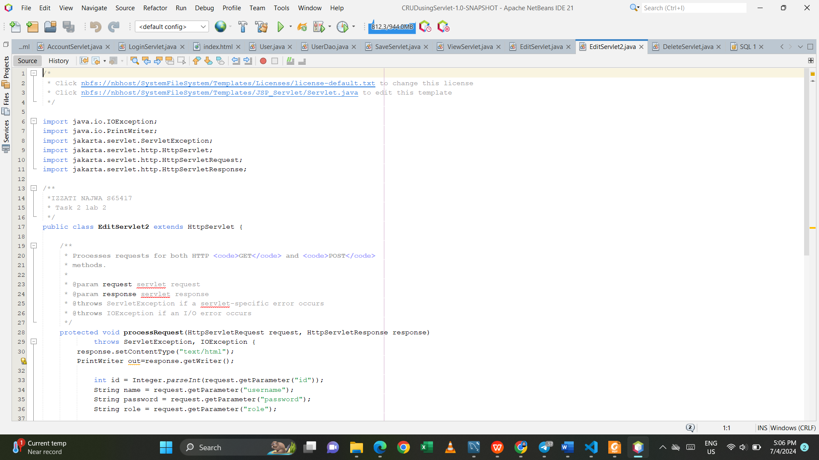

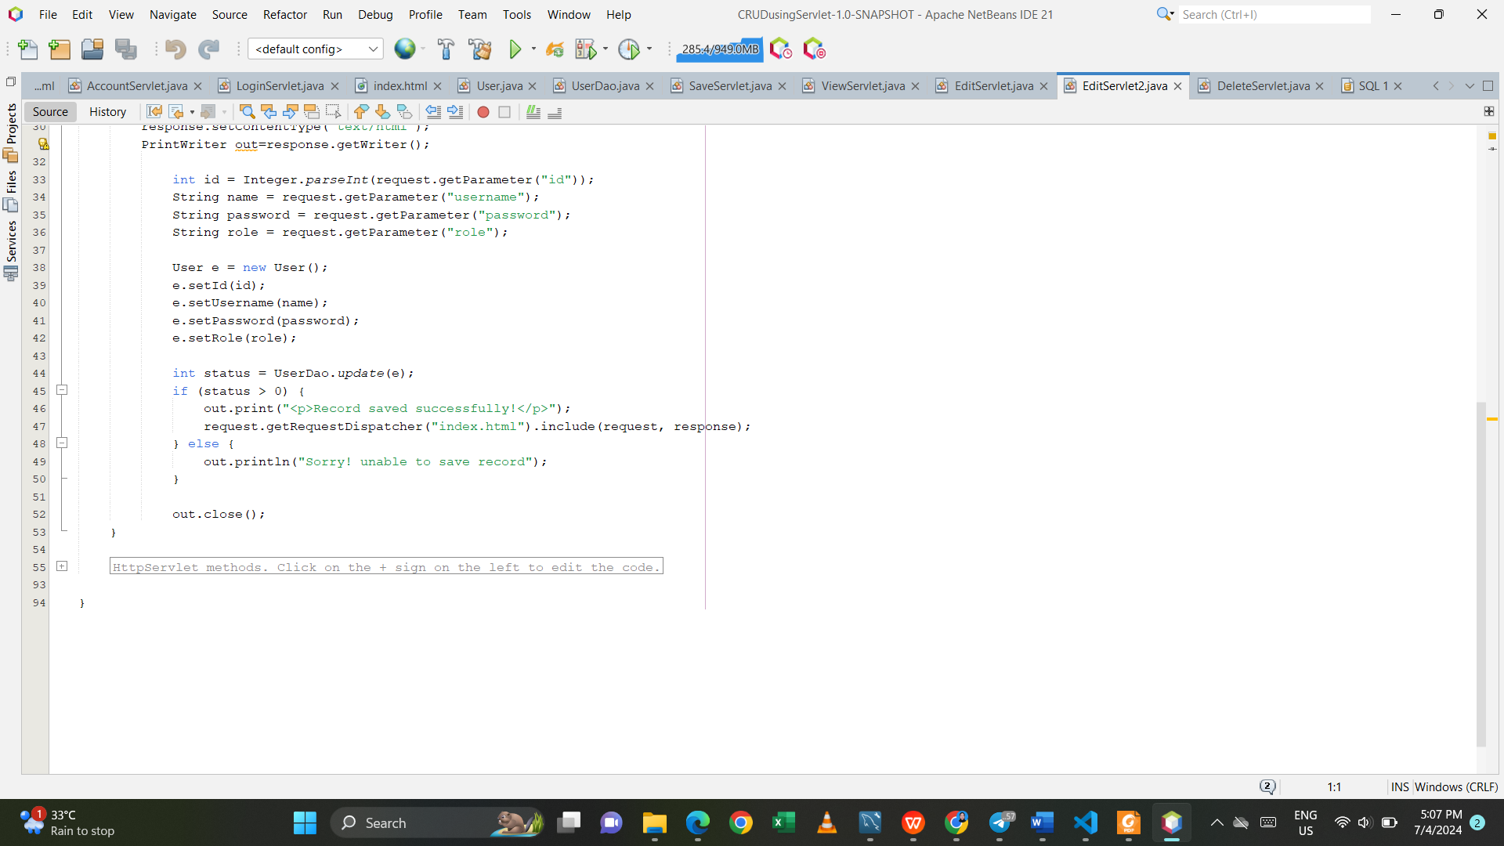

DeleteServlet.java

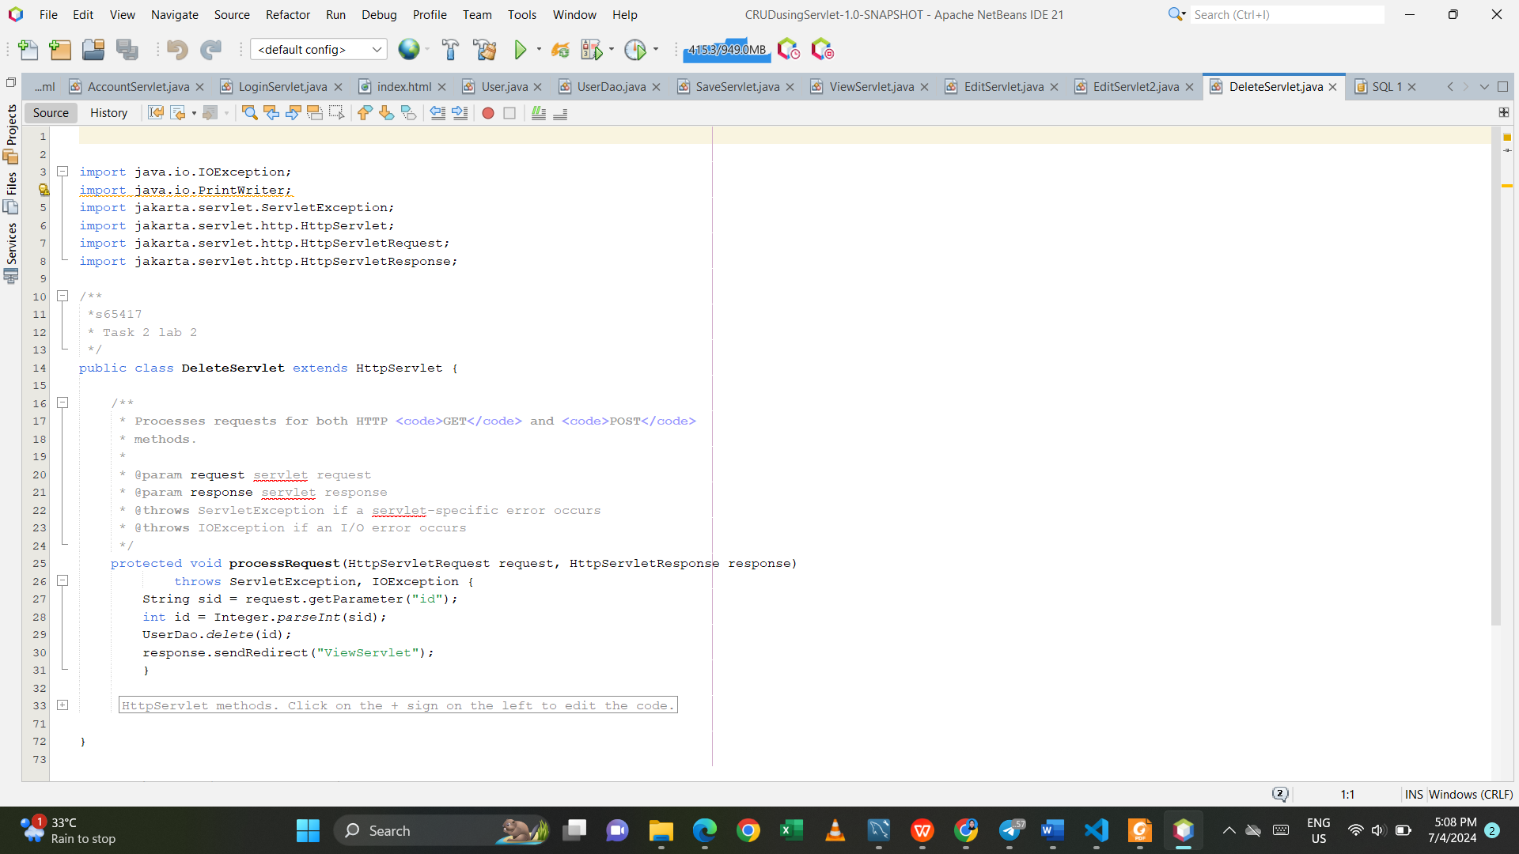

Output:

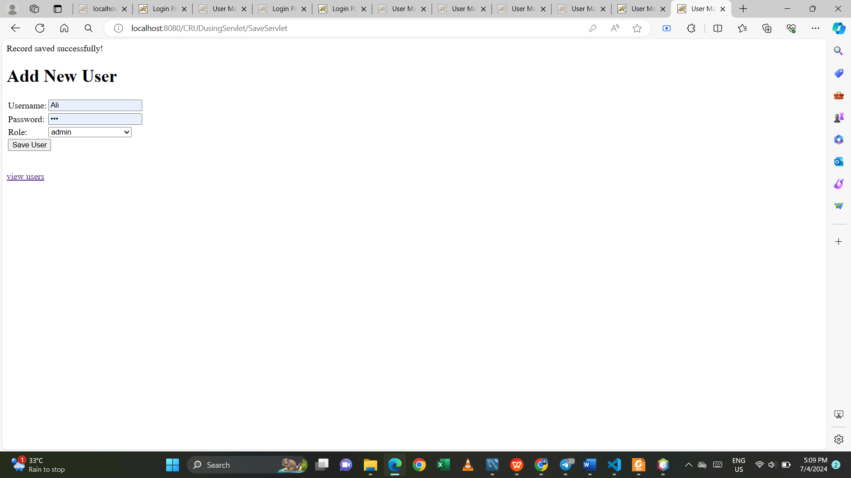

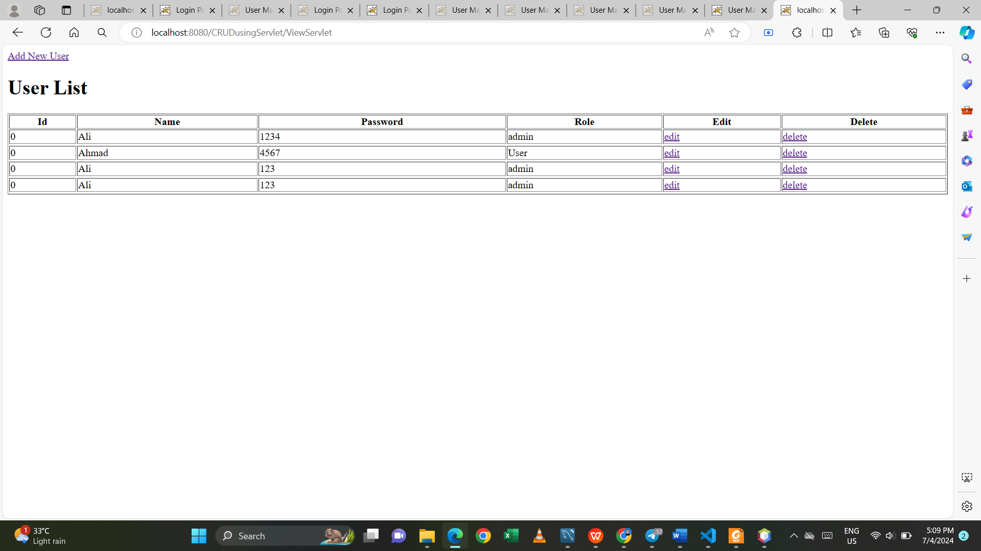

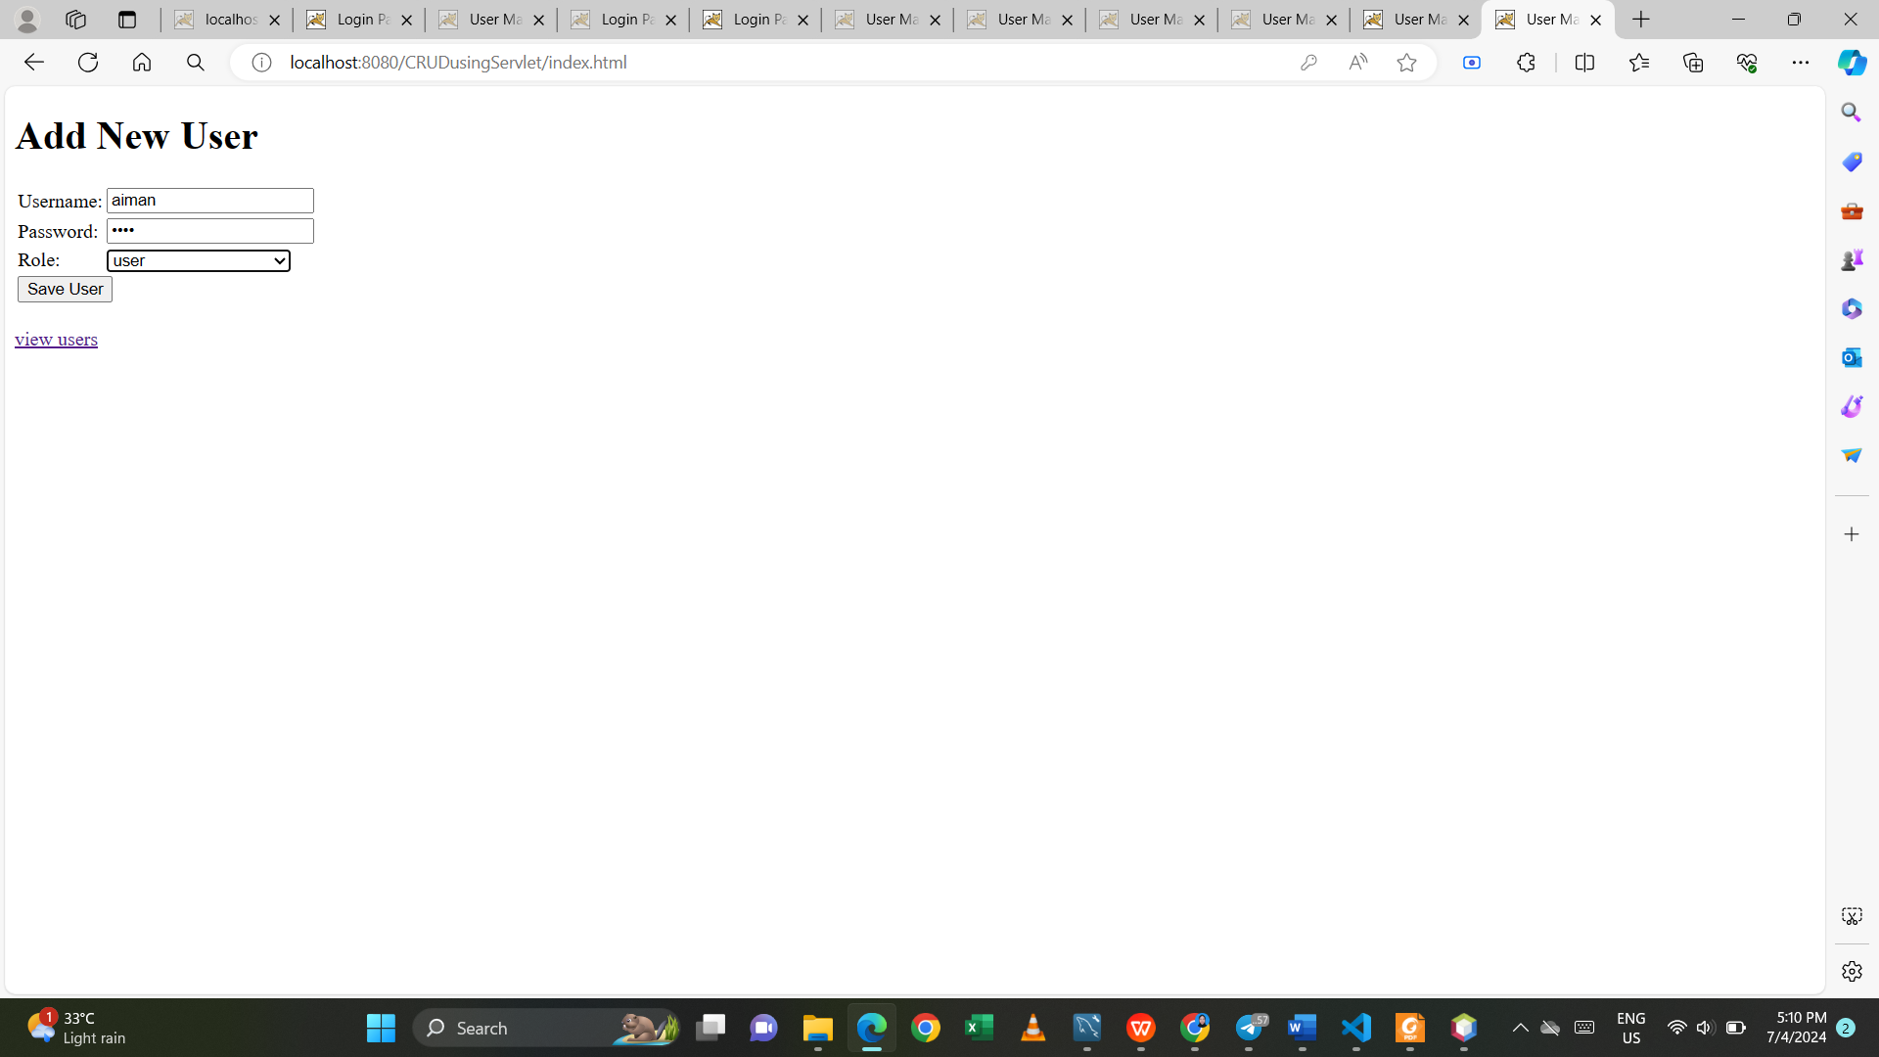

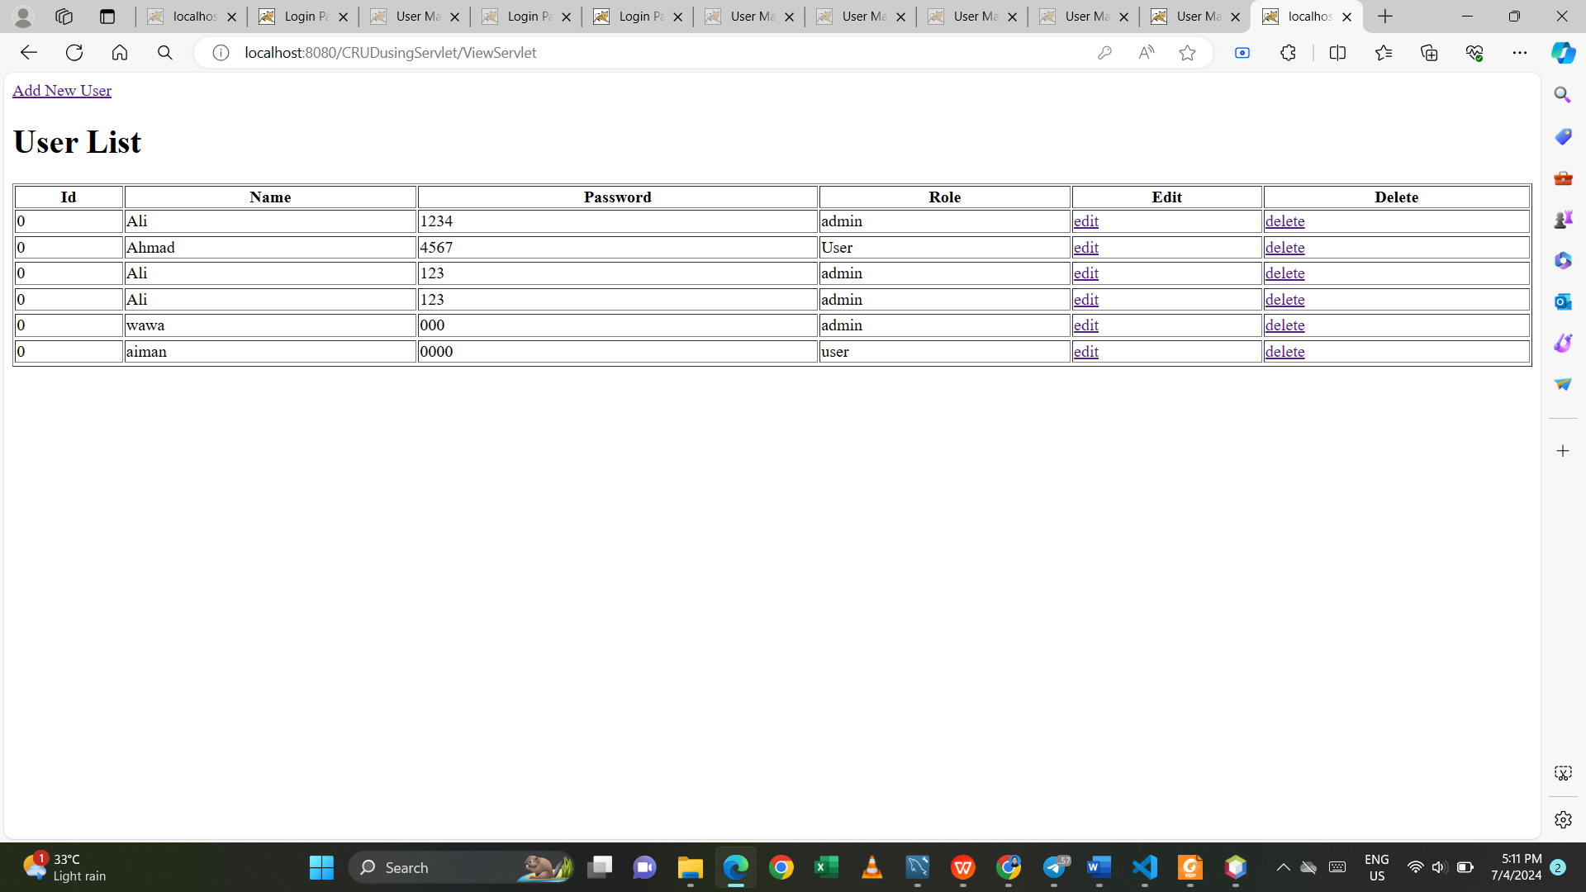

# Reflections:

1. **What is the name of the Java Library that you need to import before coding the web application with database operations?**

* The name of the Java library commonly used for database operations in web applications is "Java Database Connectivity" (JDBC).

1. **Which folder keeps the web.xml file? Copy the contents of the file and explain in brief the tags included such as <servlet-name><servlet-class><servlet-mapping>. etc.**

* The web.xml file is kept in the "WEB-INF" folder of a Java web application.

1. **Define the usage of Data Access Object (DAO) servlet. How it ease the business process in your servlet-based web application?**

* The usage of DAO servlets eases the business process in a servlet-based web application by promoting modularity and reusability. DAO servlets facilitate code reuse, as database access logic can be shared across multiple servlets or even multiple applications.

Github link:

**Sharing in Servlet**